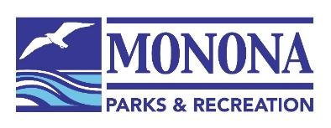
WPRA
Parr 3 Meeting – Friday December 11, 2020
Virtual Meeting - ZOOM

9:00 – 9:15 am Welcome & WPRA Reports
9:15 – 10:00 am Monona Bank RiverRink – From Dream to Reality
Monona Parks & Recreation Staff will showcase the construction and operating of the Monona BankRiver Rink and tips on how to bring a refrigerated ice rink to your community!
10:00 am – 10:15 am Break
10:15 – 11:15 pm Winter Recreation Roundtable
Program ideas for winter recreation with Public Health Limitations and Covid-19
11:15 am Closing

